**PRAKTIKUM ALGORITMA STRUKTUR DATA**

**TEKNIK INFORMATIKA**

**(Contoh)**



Oleh :

Faathir Akbar Nugroho

4522210033

Kelas A

**Pseudocode (Contoh 1)**

**Kamus/Deklarasi Variabel Function Fatirmerge_sort (int Fatirlow, int Fatirhigh)**

Fatirlow, Fatirhigh, Fatirmid = int

**Algoritma/Deskripsi Function Fatirmerge_sort (int Fatirlow, int Fatirhigh)**

if (Fatirlow<Fatirhigh)

Fatirmid = (Fatirlow+Fatirhigh)/2

Fatirmerge_sort(Fatirlow, Fatirmid)

Fatirmerge_sort(Fatirmid+1, Fatirhigh)

Fatirmerge(Fatirlow,Fatirmid,Fatirhigh)

endif

**Kamus/Deklarasi Variabel Function Fatirmerge(int Fatirlow, int Fatirmid, int Fatirhigh)**

Fatirh, Fatiri, Fatirj, Fatirb[], Fatirk = int

**Algoritma/Deskripsi Function Fatirmerge(int Fatirlow, int Fatirmid, int Fatirhigh)**

Fatirh = Fatirlow

Fatiri = Fatirlow

Fatirj = Fatirmid+1

while ((Fatirh<=Fatirmid)&&(Fatirj<=Fatirhigh))

if(Fatira[Fatirh]<=Fatira[Fatirj])

Fatirb[Fatiri]=Fatira[Fatirh]

Fatirh++

else

Fatirb[Fatiri]=Fatira[Fatirj]

Fatirj++

endif

Fatiri++

endwhile

if (Fatirh>Fatirmid)

for(Fatirk=Fatirj; Fatirk<=Fatirhigh; Fatirk++)

Fatirb[Fatiri]=Fatira[Fatirk]

Fatiri++

endfor

else

for(Fatirk=Fatirh; Fatirk<=Fatirmid; Fatirk++)

Fatirb[Fatiri]=Fatira[Fatirk]

Fatiri++

endfor

endif

for(Fatirk=Fatirlow; Fatirk<=Fatirhigh; Fatirk++)

Fatira[Fatirk]=Fatirb[Fatirk]

endfor

**Kamus/Deklarasi Variabel**

Fatira[], Fatirnum, Fatiri = int

Fatirmerge(int,int,int) = void

**Algoritma/Deskripsi**

input(Fatirnum)

print(Fatirnum)

for (Fatiri=1; Fatiri<=Fatirnum; Fatiri++)

input(Fatira[Fatiri])

endfor

Fatirmerge_sort(1,Fatirnum)

for (Fatiri=1; Fatiri<=Fatirnum; Fatiri++)

print(Fatira[Fatiri])

endfor

**Algoritma/Bahasa Natural (Contoh 1)**

1. Membuat function Fatirmerge_sort (int Fatirlow, int Fatirhigh)
2. Jika (Fatirlow<Fatirhigh), maka kerjakan baris 3 s.d 6, kalau tidak kerjakan baris 7
3. Fatirmid = (Fatirlow+Fatirhigh)/2
4. Fatirmerge_sort(Fatirlow, Fatirmid)
5. Fatirmerge_sort(Fatirmid+1, Fatirhigh)
6. Fatirmerge(Fatirlow,Fatirmid,Fatirhigh
7. Membuat function Fatirmerge(int Fatirlow, int Fatirmid, int Fatirhigh)
8. Fatirh = Fatirlow
9. Fatiri = Fatirlow
10. Fatirj = Fatirmid+1
11. Selama ((Fatirh<=Fatirmid)&&(Fatirj<=Fatirhigh)), maka kerjakan baris 12 s.d 17, kalau tidak kerjakan baris 18
12. Jika (Fatira[Fatirh]<=Fatira[Fatirj]), maka kerjakan baris 13 s.d 14, kalau tidak kerjakan baris 15 s.d 16
13. Fatirb[Fatiri]=Fatira[Fatirh]
14. Fatirh++
15. Fatirb[Fatiri]=Fatira[Fatirj]
16. Fatirj++
17. Fatiri++
18. Jika (Fatirh>Fatirmid), maka kerjakan baris 19 s.d 23, kalau tidak kerjakan baris 24
19. Fatirk=Fatirj
20. Selama (Fatirk<=Fatirhigh), maka kerjakan baris 21 s.d 22, kalau tidak kerjakan baris 23
21. Fatirb[Fatiri]=Fatira[Fatirk]
22. Fatiri++
23. Fatirk++
24. Fatirk=Fatirh
25. Selama (Fatirk<=Fatirmid), maka kerjakan baris 26 s.d 28, kalau tidak kerjakan baris 29
26. Fatirb[Fatiri]=Fatira[Fatirk]
27. Fatiri++
28. Fatirk++
29. Fatirk=Fatirlow
30. Selama (Fatirk<=Fatirhigh), maka kerjakan baris 31 s.d 32, kalau tidak kerjakan baris 33
31. Fatira[Fatirk]=Fatirb[Fatirk]
32. Fatirk++
33. Memasukkan isi/nilai variabel Fatirnum
34. Menampilkan isi/nilai variabel Fatirnum
35. Fatiri=1
36. Selama (Fatiri<=Fatirnum), maka kerjakan baris 37 s.d 38, kalau tidak kerjakan baris 39
37. Memasukkan isi/nilai variabel (Fatira[Fatiri])
38. Fatiri++
39. Memanggil function Fatirmerge_sort(1,Fatirnum)
40. Fatiri=1
41. Selama (Fatiri<=Fatirnum), maka kerjakan baris 42 s.d 43, kalau tidak kerjakan baris 44
42. Menampilkan isi/nilai variabel (Fatira[Fatiri])
43. Fatiri++
44. Selesai

**Program (Contoh 1)**

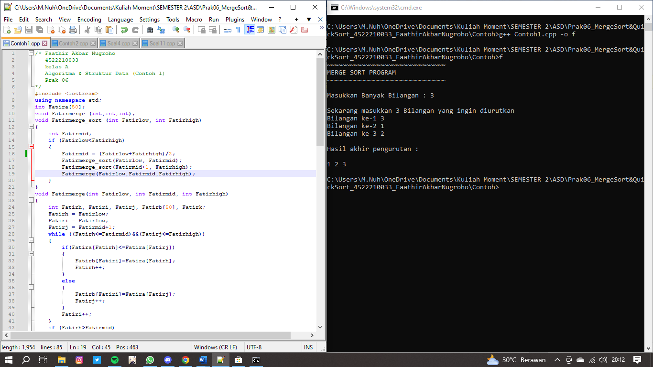

**Pseudocode (Contoh 2)**

**Kamus/Deklarasi Variabel Function Fatirq_sort(int FatirNumbers[], int Fatirleft, int Fatirright)**

FatirNumbers[], Fatirleft, Fatirright, Fatirpivot, Fatirl_hold, Fatir_hold = int

**Algoritma/Deskripsi Function Fatirmerge_sort (int Fatirlow, int Fatirhigh)**

Fatirl_hold=Fatirleft

Fatir_hold=Fatirright

Fatirpivot=FatirNumbers[Fatirleft]

while (Fatirleft<Fatirright)

while((FatirNumbers[Fatirright]>=Fatirpivot)&&(Fatirleft<Fatirright))

Fatirright--

if(Fatirleft!= Fatirright)

FatirNumbers[Fatirleft]=FatirNumbers[Fatirright]

Fatirleft++

endif

while((FatirNumbers[Fatirleft] <= Fatirpivot)&&(Fatirleft<Fatirright))

Fatirleft++

endwhile

if(Fatirleft!=Fatirright)

FatirNumbers[Fatirright]=FatirNumbers[Fatirleft]

Fatirright--

endif

endwhile

FatirNumbers[Fatirleft]=Fatirpivot

Fatirpivot=Fatirleft

Fatirleft=Fatirl_hold

Fatirright=Fatir_hold

if (Fatirleft<Fatirpivot)

Fatirq_sort(FatirNumbers,Fatirleft,Fatirpivot-1)

endif

if (Fatirright>Fatirpivot)

Fatirq_sort(FatirNumbers, Fatirpivot+1, Fatirright)

endif

**Kamus/Deklarasi Variabel**

FatirNumList = int

Fatirq_sort(int[], int, int) = void

**Algoritma/Deskripsi**

FatirNumList[9]={65,2,44,26,19,22,5,3,12}

for(int Fatird=0; Fatird<9;Fatird++)

print(FatirNumList[Fatird])

endfor

Fatirq_sort(FatirNumList,0,9)

for(int Fatiri=0; Fatiri<10; Fatiri++)

print(FatirNumList[Fatiri])

endfor

**Algoritma/Bahasa Natural (Contoh 2)**

1. Membuat function Fatirq_sort(int FatirNumbers[], int Fatirleft, int Fatirright)
2. Fatirl_hold=Fatirleft
3. Fatir_hold=Fatirright
4. Fatirpivot=FatirNumbers[Fatirleft]
5. Selama (Fatirleft<Fatirright), maka kerjakan baris 6 s.d 15, kalau tidak kerjakan baris 16
6. Selama ((FatirNumbers[Fatirright]>=Fatirpivot)&&(Fatirleft<Fatirright)), maka kerjakan baris 7, kalau tidak kerjakan baris 8
7. Fatirright--
8. Jika (Fatirleft!= Fatirright), maka kerjakan baris 9 s.d 10, kalau tidak kerjakan baris 11
9. FatirNumbers[Fatirleft]=FatirNumbers[Fatirright];
10. Fatirleft++
11. Selama ((FatirNumbers[Fatirleft] <= Fatirpivot)&&(Fatirleft<Fatirright)), maka kerjakan baris 12, kalau tidak kerjakan baris 13
12. Fatirleft++
13. Jika (Fatirleft!=Fatirright), maka kerjakan baris 14 s.d 15, kalau tidak kerjakan baris 16
14. FatirNumbers[Fatirright]=FatirNumbers[Fatirleft];
15. Fatirright--
16. FatirNumbers[Fatirleft]=Fatirpivot
17. Fatirpivot=Fatirleft
18. Fatirleft=Fatirl_hold
19. Fatirright=Fatir_hold
20. Jika (Fatirleft<Fatirpivot), maka kerjakan baris 21, kalau tidak kerjakan baris 22
21. Fatirq_sort(FatirNumbers,Fatirleft,Fatirpivot-1)
22. Jika (Fatirright>Fatirpivot), maka kerjakan baris 23, kalau tidak kerjakan baris 24
23. Fatirq_sort(FatirNumbers, Fatirpivot+1, Fatirright)
24. FatirNumList[9]={65,2,44,26,19,22,5,3,12}
25. Fatird=0
26. Selama (Fatird<9), maka kerjakan baris 27 s.d 28, kalau tidak kerjakan baris 29
27. Menampilkan isi/nilai variabel (FatirNumList[Fatird])
28. Fatird++
29. Memanggil function Fatirq_sort(FatirNumList,0,9)
30. Fatiri=0
31. Selama (Fatiri<9), maka kerjakan baris 31 s.d 33, kalau tidak kerjakan baris 34
32. Menampilkan isi/nilai variabel (FatirNumList[Fatiri])
33. Fatiri++
34. Selesai

**Program (Contoh 2)**

